
T 03 9572 0002
A 87& 97 Waverley Road
Malvern East VIC 3145
E Douglas@auvinvestment.com

Rental Appraisal

Property address: 211 / 951 Dandenong Road

Property Type: 2 Bedroom, 1 Bathroom, 1 Car space
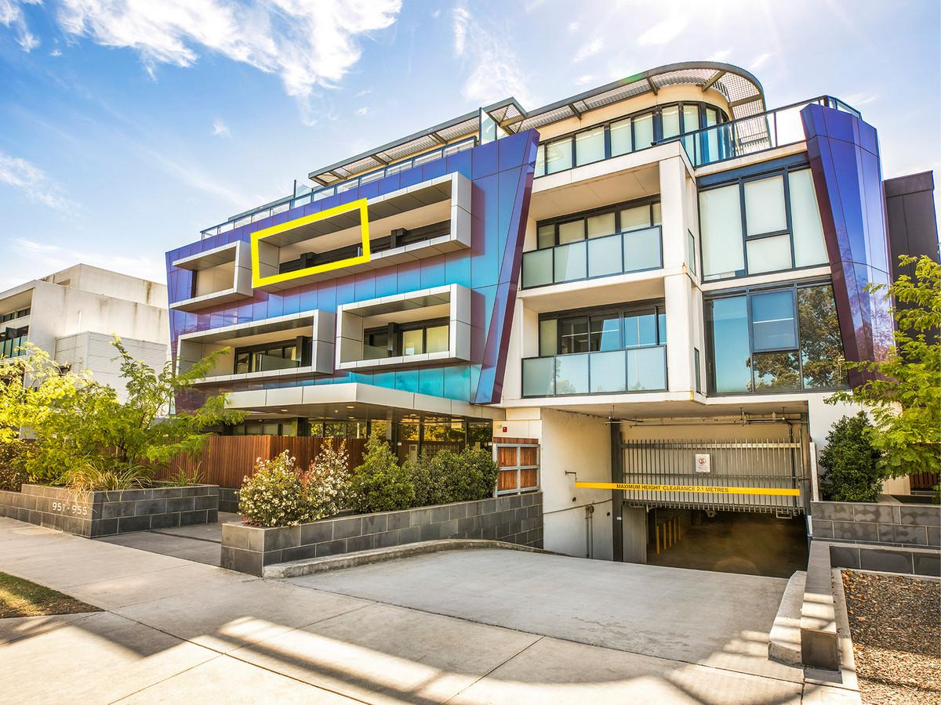
Based on current and comparative rental yields in the Malvern East area, 951 Dandenong Road can be expected to return anywhere between:
AUV Estimated Rental Target $450 pw

Comparables Rental Properties On the Market
Rent Address Prperty Type
$350/wk 09/800 Warrigal Road, Malvern East Type: 2 Bedroom, 1 Bathroom, 1 Car space
$390/wk 04 / 3 Burke Road, Malvern East Type: 2 Bedroom, 1 Bathroom, 1 Car space
$345/wk 07/780 Warrigal Road, Malvern East Type: 2 Bedroom, 1 Bathroom, 1 Car space

Douglas Tan
Property Manager
E : Douglas@auvinvestment.com
P : 9572 0002
M: 0403 421 322
DISCLAIMER – 1. This assessment is an opinion only of the rental valuation of the above mentioned property.
2. The assessment of the rental value is merely an indication of market value, whereas real market value can only be determined by the amount that a willing tenant is actually prepared to pay for leasing the property.
3. The accuracy of the information obtained from a third party and is used in the preparation of the appraisal of value cannot be guaranteed.

